1. Spandan / Kimoy (Rau) *Go up with #2
Welcome to the Third Grade Informance! We ask that you only talk or get up from your seat during applause so that everyone can enjoy listening to our new knowledge and skills gained in music class this year. We are very excited to share what we have learned so far!
2. Violet / Evie (Rau) *Go up with #1
“America the Beautiful” was written by Professor Katherine Lee Bates in 1913 after observing the view from the top of Pike’s Peak. We learned to sing the most familiar first verse as well as verse two, which is about the heroes who put our country above themselves.
America the Beautiful
O beautiful for spacious skies, for amber waves of grain,
for purple mountain majesties above the fruited plain!
America! America! God shed his grace on thee
and crown thy good with brotherhood from sea to shining sea!
O beautiful for heroes proved, in liberating strife,
Who more than self their country loved, and mercy more than life.
America! America! May God thy gold refine
‘Till all success be nobleness, and every gain divine.

3. Yashwanth / Mumtaz (Rau) Go with #4
We studied the life and music of John Phillip Sousa. He was an American composer who started his career in the Marine Band. He later started a concert band and toured all over the world. We enjoyed listening to and moving to his most famous piece, “The Stars and Stripes Forever.”

4. Janella / Kimoy (Rau) Go with #3
Our next two songs are both from the turn of the 20th century. “A Bicycle Built for Two” and “In the Good Old Summertime” both start with a verse that will be sung by a small group of lead singers and the chorus will be sung by everyone.

In the Good Old Summertime
Schmidt: Anzil, Melissa, Dheekshi, Dharshana
There's a time in each year that we always hold dear, good old summer time
Murray: Libby, Bella, Lillian, Reagan
With the birds and the trees-es, and sweet scented breezes, good old summer time
Rau: Adell, Elise, Punya
When you day's work is over, ghen you are in clover, and life is one beautiful rhyme
Schmidt: Arina, Aasrita, Chloe, Scottlynn
No trouble annoying, each one is enjoying, the good old summer time
Chorus: All 3rd grade students
In the good old summertime, in the good old summertime.
Strolling through the shady lanes, with your baby mine.
You hold her hand and she holds yours, and that's a very good sign.
That she's your tootsie-wootsie, in the good old summertime.

5. Andrew/Mariaan (Schloesser)
“Li’l Liza Jane” was composed in 1916. We noticed clear verses and choruses in this song. We also learned to accompany “Little Liza Jane” with boom whackers. Some students will play the alternating bass line, while others play a rhythm that follows the downbeats and the syncopated rhythm of the words “Li’l Liza Jane.”

Li'l Liza Jane
- I got a house in Baltimore, Li'l Liza Jane,
streetcars running by my door, Li'l Liza Jane.
(rest)Oh, Eliza, Li'l Liza Jane, (rest)Oh, Eliza, Li'l Liza Jane.
- Brussels carpet on my floor, Li'l Liza Jane,
Silver doorplate by my door, Li'l Liza Jane.
(rest) Oh, Eliza, Li'l Liza Jane, (rest) Oh, Eliza, Li'l Liza Jane.
- Come my love, and be with me, Li'l Liza Jane,
Let me take good care of thee, Li'l Liza Jane.
(rest) Oh, Eliza, Li'l Liza Jane, (rest) Oh, Eliza, Li'l Liza Jane.
Syncopated Rhythm (top) |  |  | Down Beats (1 and 3) |  |  | Off Beats (2 and 4)
Elizabeth | Madson |  | Clara | Rau |  | Milo J | Rau
Dominika | Schmidt |  | Eric | Madson |  | Nola | Madson
Meha | Mr. S |  | Hashim | Murray |  | Abdulahi | Murray
Carson | Madson |  | Bravin | Murray |  | Arnav | Mr. S
Aahil | Rau |  | Mohamed | Mr. S |  | Brayden | Mr. S
Phillip I | Madson |  | Nikita | Mr. S |  | Nikhil | Mr. S
Darshiv | Mr. S |  | Avi | Mr. S |  | Vineet | Mr. S
Eshanthsai | Mr. S |  | Ekansh | Schmidt |  | Rishab | Schmidt
 |  |  | Sugulle | Madson
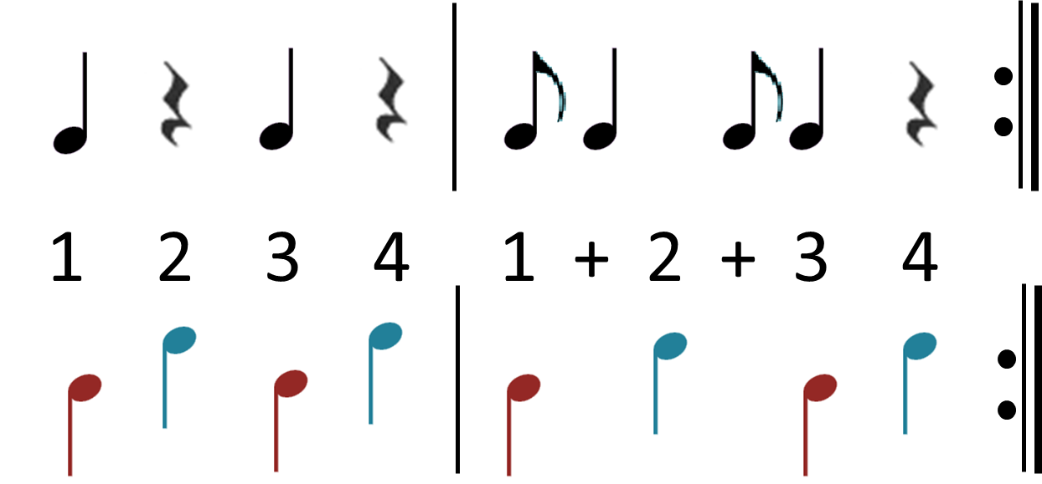

6. Rohana/Nicole (Schloesser)
“This Little Light of Mine” is a spiritual that was first sung by slaves about 200 years ago. Since then it has been arranged many times and published in many songbooks. We noticed that it is an inspirational song that could be linked to our pillars of Excellence, Integrity, and Citizenship.

This Li'l Light of Mine
This Li'l light of mine I'm gonna let it shine (3 times)
Let it shine, Let it shine, Let it shine.
Don’t you blow it out I'm gonna let it shine (3 times)
Let it shine, Let it shine, Let it shine.

Ev’ry where I go I'm gonna let it shine (3 times)
Let it shine, Let it shine, Let it shine.
7. Chloe/Mariaan (Schloesser) With #8 (Murray)
The next composer we studied was Aaron Copland. He was an American composer who wrote music for ballets and movies in addition to works for concert halls. We enjoyed listening to his “Hoe Down,” “Appalachian Spring” and “Fanfare for the Common Man.” We noticed how he featured brass and woodwind instruments, which are the two instrument families we studied this year.
8. Ariya / Aisha (Murray) With #7 (Schloesser)
Simple Gifts is a Shaker song written in 1848 and has also been called “Lord of the Dance.” We heard this beautiful melody in Aaron Copland's “Appalachian Spring” and John Williams’ “Air and Simple Gifts.” This song also reminds us of the pillars of Perseverance, Honor, and Respect.

Simple Gifts
'Tis the gift to be simple, 'tis the gift to be free,
'Tis the gift to come down where we ought to be,
And when we find ourselves in the place just right,
'Twill be in the valley of love and delight.
When———true——— simplicity is gained,
To bow and to bend we shan't be ashamed,
To turn———, turn——— will be our delight,
Till by turning, turning we come round right.
9. Maqsud / Zara (Murray)
For our next song, small groups of lead singers will sing each verse and everyone will join in on the chorus. “Polly Wolly Doodle” is a fun song. It is full of nonsense words that had students wondering if they were reading the lyrics correctly!

Polly Wolly Doodle
1. Rau: Zuber, Ryan, Aidan
Oh, I went down South for to see my Sal Sing Polly wolly doodle all the day
my Sal, she is a spunky gal Sing Polly wolly doodle all the day
Polly Wolly Doodle Chorus: All students sing after each verse
Fare thee well, Fare thee well, Fare thee well my fairy fay
For I'm go’n to Lou'siana for to see my Susyanna Sing Polly Wolly Doodle all the day

2. Schloesser: Rachel, Maria, Rithikaa
Oh, my Sal, she is a maiden fair sing Polly Wolly Doodle all the day
with curly eyes and laughing hair sing Polly Wolly Doodle all the day
3. Murray: Audrey, Ashritha, Calin, Yash
Behind the barn, down on my knees, sing Polly Wolly Doodle all the day
I thought I heard a chicken sneeze, sing Polly Wolly Doodle all the day
4. Kaiser: Hadyat, Sophia, Devanshu, Aniah
He sneezed so hard, with the whoopin’ cough, sing Polly Wolly Doodle all the day
He sneezed his head and the tail right off, sing Polly Wolly Doodle all the day
5. Schmidt: Gabe, William, Anirudh
Oh, a grasshopper sittin’ on a railroad track, sing Polly Wolly Doodle all the day
A pickin’ his teeth with a carpet tack, sing Polly Wolly Doodle all the day

10. Lily / Maximus (Madson)
“Alouette” is a song from the French Canadian culture. We also study Canada in World History and Geography in 3rd Grade. We will sing the song in French today, but we also learned the English translation, which tells the story of a bird being plucked apart!
Alouette Chorus: All students sing before and after each verse
Pronunciation
Je = Zhah
te = Tay
plumerai = plume ah ray
La = Lah
Tete = Tet
Le = Lay
Dos = Doh
Les pattes = Lay Pot
Les ailes = Lay-z ails
Alouette, gentille Alouette, Alouette je te plumerai
Alouette, gentille Alouette, Alouette je te plumerai

*Numbered groups sing call, all sing response*
1. Je te plumerai la tete, Je te plumerai la tete
1. Et la tete, et la tete
6. Alouette, Alouette, O-o-o-oh
2. Je te plumerai le bec, Je te plumerai le bec
1. Et la tete, et la tete
- (Rau) Neeraj, Vijay, Olivia
- (Mr. S) Avrie, Shailee, Syon
- (Murray) Luke, Bhadri, Bhavik
- (Madson) Krithik, Anders, Charith
- (Madson) Vivian, Darun, Anna
- (Schmidt) Parth, Srilakshmi, Abigail
2. Et le bec, et le bec
6. Alouette, Alouette, O-o-o-oh
3. Je te plumerai le dos, Je te plumerai le dos
1—2 same as above
3. Et le dos, Et le dos
6. Alouette, Alouette, O-o-o-oh
4. Je te plumerai les pattes, Je te plumerai les pattes
1—3 same as above
4. Et les pattes, Et les pattes
6. Alouette, Alouette, O-o-o-oh
5. Je te plumerai les ailes, Je te plumerai les ailes
1—4 same as above
5. Et les ailes, Et les ailes
6. Alouette, Alouette, O-o-o-oh

11. Victoria/Alex (Mad./Sch.)
We learned to sing in rounds through the songs “Row Your Boat,” (Fray-rah Zhock-ah) “Frere Jacques,” and “Hey, Ho, Nobody Home.” We can hear harmonies when we sing rounds, especially when our voices are balanced and focused on pitch. Our next piece is the round “Hey, Ho, Nobody Home.”
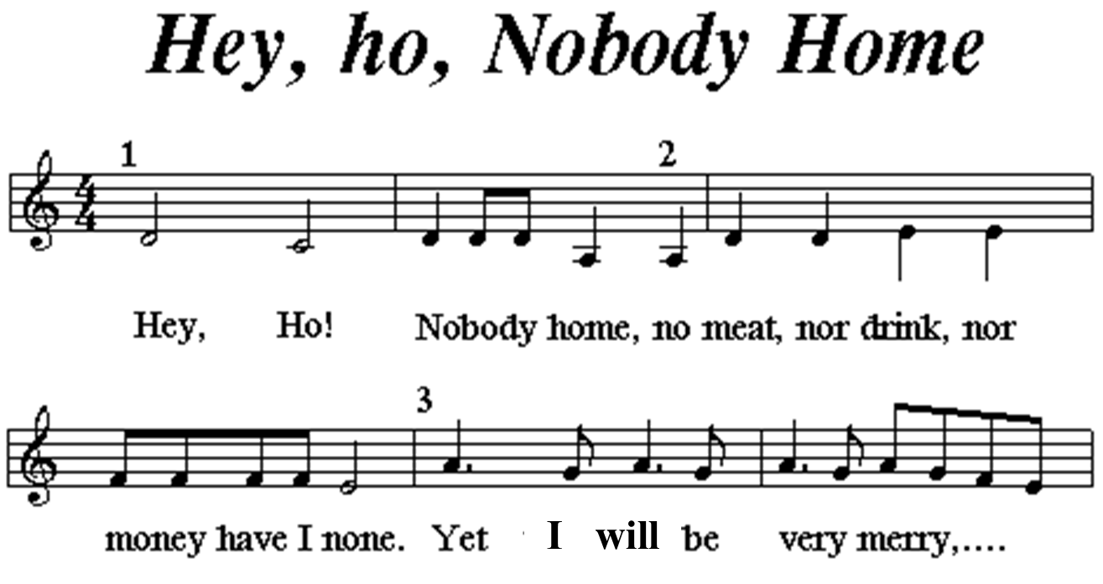

Singing this song in round form

All 3 groups sing the song twice, in unison (same lyrics and melody at the same time.)

Group 1 (Rau plus most of Mr. S) starts the round, singing the song twice and ending after singing section 1 a final time (the final lyric sang is “home.”)

Group 2 (Arnav, Meha, Eshanthsai, Rohana, Brayden, Sritha, Mariaan, Nikhil from Schloesser, all of Murray, Carson, Lily, Sugulle, Ramyashree, Maximus, Sela, Devanshu, and Hadyat from Madson) starts when Group 1 gets to section 2 (“No…”).

Group 3 (the rest of Madson and all of Schmidt) starts when Group 2 gets to section 2 (“No…”) and Group 1 gets to section 3 (“Yet…”).

12. Haran / Viggo (Schmidt)
Thank you for watching our Informance! We hope you enjoyed learning more about our 3rd grade music experience. If you haven’t done an art walk through the music hallway and commons, be sure to do that before you go. Have a great night!

