1. **Sai (Madigan)**: *Go up with #2*

Welcome to the Fourth Grade Informance! We ask that you only talk or get up from your seat during applause so that everyone can enjoy listening to our new knowledge and skills gained in music class this year. We are very excited to share what we have learned so far!

1. **Akshit (Madigan):** *Go up with #1*

Many of the songs we learned this year come from the 19th Century and early 20th Century. My Grandfather’s Clock was written in 1874. At that time, grandfather clocks were known as long-case clocks, but the popularity of this song gave it a new name! This song also gave us an opportunity to apply dynamics and articulations to a song.

**My Grandfather's Clock**

My grandfather's clock, was too large for the shelf,

So it stood ninety years on the floor

It was taller by half, than the old man himself,

Though it weighed not a pennyweight more

It was bought on the morn of the day that he was born,

It was always his treasure and pride

But it stopped short, never to go again,

When the old man died.

Ninety years without slumbering,

Tick, tock, tick, tock,

His life seconds numbering,

Tick, tock, tick, tock,

It stopped short, never to go again,

When the old man died.

1. **Aaron (Madigan):** We have learned to sing in rounds through the songs (Fray-rah Zhock-ah) “Frere Jacques,” “Hey, Ho, Nobody Home” and “I Love the Mountains.” We found that harmonies occur when we sing in rounds, especially when our voices are balanced and focused on pitch. Our next piece is a round called “I Love the Mountains.”
2. **Liam (Walker):** *After “I Love the Mountains” with #5*Just before Veteran’s Day, welistened to “Taps” andlearned about the history of the most famous military bugle call. The tradition of playing it at the end of the day and at funerals dates back to the Civil War. We also listened to the songs of all of the branches of the American military. We heard them performed live by the Eagle Ridge Academy Orchestra at the Veteran’s Day Assembly.

|  |  |  |
| --- | --- | --- |
| **I Love the Mountains**  I love the mountains,  I love the rolling hills  I love the flowers  I love the daffodils  I love the fireside  When all the lights are low  Boom de-ah-da  Boom de-ah-da  Boom de-ah-da  Boom de-ah-da :||  Boom (3rd time) | **“I Love the Mountains”**  Madigan  Lily  Walker  Joey, Brinda  Sorenson  Annabelle, Vandana, Sujayaa  Feist  Tanya Olson  Jihaan, Rayce | **Drum and Bell Players for “One Bottle of Pop”**  Madigan  William = bells Hardhik+Sumaya=drums  Walker  Hamza=bells Rohan=drum  Sorenson  Joshua+Dylan=drum Sriyan+Lilia=bells Prag+Armaan=drum  Feist  Aarush=drum Makiyah=bells  Olson  Maryan+Alyssa=bells Shivam=drum |

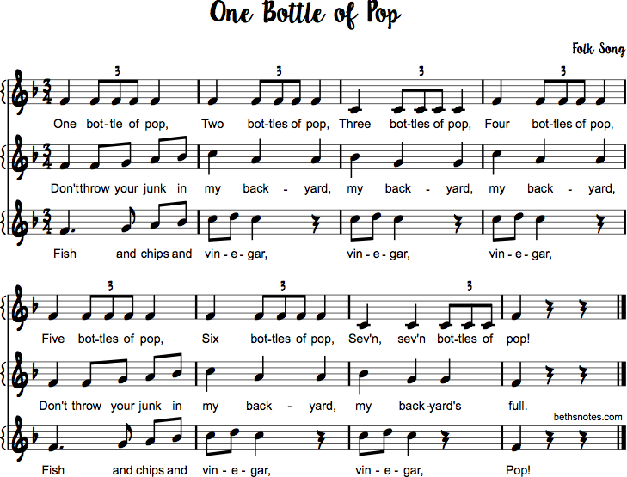

Pepper pepper pepper salt

bot-tles of pop, pop!

1. **Karolina (Walker):** *After “I Love the Mountains,” with #4*  
   The next song is another round that we learned to sing. It combines three short songs called “One Bottle of Pop,” “Don’t Throw Your Junk,” and “Fish and Chips.” Students have volunteered to play drums and bells while we sing to keep our beat steady and pitches together.
2. **Roman (Sorenson):** *After “One Bottle of Pop” round and with #7*

In order to prepare for watching Mozart’s opera, “The Magic Flute,” we learned about the six vocal ranges; Soprano, Mezzo Soprano, Alto, Tenor, Baritone and Bass. We also learned about how an Opera is produced; bringing together writers, musicians, directors and businesses.

**7. Joe (Madigan):** *After “One Bottle of Pop” round and with #6*  
Our next song is the most famous song from Australia, “Waltzing Matilda.” We had fun learning Australian terminology and singing in the form of a story-teller. Small groups of volunteer singers will sing each verse and the entire fourth grade will sing each chorus.

**Waltzing Matilda**

**Verse 1:** (Madigan/Sorenson) Cora, Marcel, AbbyOnce a jolly swagman camped by a billabong, under the shade of a Coolibah tree,  
And he sang as he watched and waited 'til his billy boiled, "You'll come a-Waltzing Matilda, with me"  
 **Chorus: Waltzing Matilda, Waltzing Matilda "You'll come a-Waltzing Matilda, with me." And he sang as he watched and waited 'til his billy boiled, "You'll come a-Waltzing Matilda, with me".**

**Verse 2:** (Walker) Hamza, Bhuvan, Annika  
Down came a jumbuck to drink at that billabong, up jumped the swagman and grabbed him with glee,  
And he sang as he shoved that jumbuck in his tucker bag, "You'll come a-Waltzing Matilda, with me".  
***Chorus*Verse 3:** (Sorenson)Shirley, Addison, Ajira  
Up rode the stockman, mounted on his thoroughbred, down came the troopers, one, two, three,  
"Where's that jolly jumbuck you've got in your tucker bag?" "You'll come a-Waltzing Matilda, with me".  
***Chorus***

**Verse 4:** (Olson) Alyssa, Maryan, Makenna  
Up jumped the swagman and sprang into the billabong, "You'll never take me alive", said he  
And his ghost may be heard as you pass by that billabong, "You'll come a-Waltzing Matilda, with me".  
***Chorus***

1. **Nitika (Feist):** In 4th Grade we study the Medieval Era in many subjects. In music class, we listened to Gregorian Chant and learned about Hildegard von Bingen, the first composer to attach her name to her (compo-zi-shuns) compositions. We also learned about Troubadours and the instruments they played.
2. **Pranav (Feist):** *With Medieval speaker, after “Waltzing Matilda”* We learned to sing “Auld Lang Syne” just before our winter break so that we could sing it on New Year’s Eve! The song was written by a Scottish composer named Robert Burns, who lived in the late 18th century. In some cultures, they sing “Auld Lang Syne” on other occasions, such as graduations, funerals and as a song to say “farewell.”

**Auld Lang Syne**

*2. Write the number of times   
each of these phrases are sung:*

we'll take a cup of kindness yet _____

Should auld acquaintance be forgot _____

never brought to mind? _____

*1. Write these phrases in the correct order into the lyrics to fill in the blanks:*

And here’s a hand, my trusty friend

days of auld lang syne?

never brought to mind?

We'll take a cup of kindness yet

Should auld acquaintance be forgot, and ___________________________________

Should auld acquaintance be forgot, and ___________________________________

**For auld lang syne, my dear, for auld lang syne,  
we'll take a cup of kindness yet, for auld lang syne.**

___________________________________________________, and give a hand of thine, __________________________________________________________, for auld lang syne.

**For auld lang syne, my dear, for auld lang syne,  
we'll take a cup of kindness yet, for auld lang syne.**

**10. Julian (Olson):**   
Another Scottish song from the 18th century is “Loch Lomond.” It tells the story of a participant in the Jacobite Rebellion who was captured and jailed by the English. He dreams of is home and his true love, but knows he will not return.

**Loch Lomond**

1. (Sorenson/Olson) Roman/Sam, Theo  
By yon bonnie banks and by yon bonnie braes

Where the sun shines bright on Loch Lomond

Where me and my true love will never meet again

On the bonnie, bonnie banks o' Loch Lomond.

***Chorus***

**O ye'll take the high road and I'll take the low road,  
An' I'll be in Scotland afore ye;  
But me and my true love will never meet again  
On the bonnie, bonnie banks of Loch Lomon'.**

2. (Walker) Rishita, Saanvi, Maleeha  
'Twas there that we parted in yon shady glen

On the steep, steep sides o' Ben Lomond

Where in purple hue, the highland hills we view

And the moon comin’ out in the gloamin’.

***Chorus***

3. (Feist) Eli, Tanya, Hannah  
The wee birdies sing an' the wild flowers spring

An' in sunshine the waters are sleeping

But the broken heart it kens, nae second spring again

Tho’ the waeful may cease frae their greeting.

***Chorus***

**11. Makena (Olson):** The song “Froggie Went a Coutin’” has been recorded by over 40musicians and has many variations. It originates from a Scottish folk song called “A Frog Came to my Door” from the middle of the 16th Century. Today we will perform the song in call and response form, with lead singers telling the story and the response simply echoing “uh-huh!”  
******************************************************************************************************  
**Thursday, May 11, 7:00-7:20pm - Grade 4 Informance in the Gym.**  
**All 4th grade students must report to their classroom by 6:50pm in formal dress.**

**Froggie Went a Courtin’**





|  |  |
| --- | --- |
| Madigan   1. Silas, Eli, Nam 2. Taylor, Elena   Walker   1. Molly, Esther   Sorenson   1. Zeba, Phoebe | Feist   1. Ashfaq, Nihal, Elliot, Sayan 2. Katie, Ruby, Aadya   Olson   1. Rhian, Lessley, Sarah, Anna |

1. **Shawn (Olson):**  
   This winter we reviewed how to play the notes G, A, B and C on the recorder. We also learned to read music on the treble clef staff, including the low E. Some students volunteered to perform on recorders before and after tonight’s Informance. Thank you for attending the 4th Grade Informance! Have a great night!

**\*\*\*\*\*\*\*\*\*\*\*\*\*\*\*\*\*\*\*\*\*\*\*\*\*\*\*\*\*\*\*\*\*\*\*\*\*\*\*\*\*\*\*\*\*\*\*\*\*\*\*\*\*\*\*\*\*\*\*\*\*\*\*\*\*\*\*\*\*\*\*\*\*\*\*\*\*\*\*\*\*\*\*\*\*\*\*\*\*\*\*\*\*\*\*\*\*\*\*\*\*\*Participation in the Informance is part of the Semester 2 music grade. Absences are only excused if it qualifies under ERA's Attendance Policy and communication between parents and Ms. Nimchuk takes place.**