2017 5th Grade Informance
Please practice by memorizing your lyrics and singing along with the 5th Grade Informance videos found under “Videos of Informances” on nimchuk.weebly.com/2016.html
Mark your calendar and share this news with your family to be sure you will be present for the 5th Grade Informance on Thursday May 4 at 7pm. Students should arrive 10 minutes early, in formal dress, for attendance in their homeroom.

Greensleeves
Alas, my love, you do me wrong, To cast me off discourteously.
For I have loved you well and long, Delighting in your company.
Greensleeves was all my joy Greensleeves was my delight,
Greensleeves was my heart of gold, And who but my lady Greensleeves.
Your vows you've broken, like my heart, Oh, why did you so enrapture me?
Now I remain in a world apart, But my heart remains in captivity.
Greensleeves was all my joy Greensleeves was my delight,
Greensleeves was my heart of gold, And who but my lady Greensleeves.

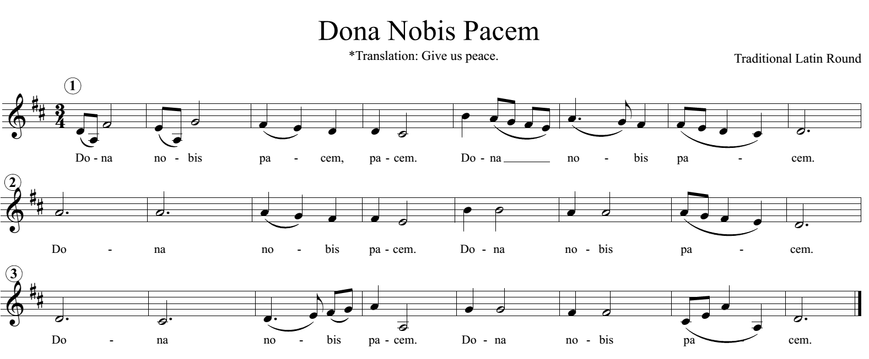

Chorus from “Git Along Little Dogies”
Whoopie-ti-yi-yo, Git along little dogies, It’s your misfortune and none of my own
Whoopie-ti-yi-yo, Git along little dogies, You know that Wyoming will be your new home
Lead singers and their verses for “Git Along, Little Dogies”
1. Molnar: Abigail, Kate, Isabelle, Veronika
As I was out walking one morning for pleasure, I saw a cowpuncher a-riding along
His hat was throwed back and his spurs were a-jingling, and as he approached he was singing this song
2. Carlson: Najma, Isabel, Elianna, Antigone, Ruby
Early in spring we round up all the dogies, we mark them and brand them and bob off their tails
We round up our horses load up the chuck wagon, and throw all them dogies right out on the trail
3. Grabanski: Srikar, Zuhayb, Logan, Anthony, Jack, Jonah, Arjan
Whooping and yelling and hounding the dogies, from sunrise till sunset and all the night long
So come now, you young’uns, get over the prairie, and keep right on hearing my beautiful song

Chorus from “Red River Valley”
Come and sit by my side, if you love me, do not hasten to bid me adieu
Just remember the Red River Valley, and the cowboy who loved you so true

Lead singers and their verses for “Red River Valley”
1. Grabanski: Lasya, Pranati, Paige
From this valley they say you are going, We will miss your bright eyes and sweet smile
For they say you are taking the sunshine, That has brightened our pathways awhile
2. Walker: Najma, Sudiksha, Emily
I've been thinking a long time, my darling, of the sweet words you never would say
Now, alas, must my fond hopes all vanish, for they say you are going away
3. Carlson/Walker: Gabriel and Owen/Tierney and Marwa
Do you think of the valley you're leaving, Oh how lonely and drear it will be
Do you think of the kind hearts you're breaking, And the pain you are causing to me

Chorus from “The Happy Wanderer”
Val-deri, Val-dera, Val-deri, Val-dera-ha-ha-ha-ha-ha
Val-deri, Val-dera. 1. My knapsack on my back 2. Come join my happy song
3. From every greenwood tree 4. As o’er the world we roam
Lead singers and their verses for “The Happy Wanderer”
1. Molnar: Aditya, Joel Grabanski: Keerthik, Allison
I love to go a-wandering, Along the mountain track,
And as I go, I love to sing, My knapsack on my back.
2. Molnar: Gabriel, Matthew, Matthew, Andrew
I love to wander by the stream That dances in the sun,
So joyously it calls to me, "Come! Join my happy song!"

3. Carlson: Vineel, Anvit, Shivsai
I wave my hat to all I meet, And they wave back to me,
And blackbirds call so loud and sweet From ev'ry green wood tree.
4. Walker: Evan, Arya, Kayden
High overhead, the skylarks wing, They never rest at home
But just like me, they love to sing, As o'er the world we roam.

De Colores – Verse 1 in Spanish
De Colores, De Colores se visten los campos en la primavera
De Colores, De Colores son los pajarillos que vienen de afuera
De Colores, De Colores es el arco iris que vemos lucir
Y por eso los grandes amores de muchos colores me gustan a mi
Y por eso los grandes amores de muchos colores me gustan a mi

De Colores – Verse 2 in English
All the colors, All the colors the bloom in the meadows are colors of springtime
All the colors, All the colors that dance in the sky are the colors of rainbows
All the colors, All the colors of nature spring forth to make my heart sing
Then I know why the colors of springtime are bringing me joy and a heart full of love
Then I know why the colors of springtime are bringing me joy and a heart full of love

“If I Had a Hammer”
Bold = Lead Singers with the call / Italicized = 5th gr. with the response
1. If I Had a Hammer I'd hammer in the morning,
I'd hammer in the evening all over this land
I'd hammer out danger, I'd hammer out warning
I'd hammer out love between my brothers and my sisters, All over this land

2. If I had a bell I'd ring it in the morning
I'd ring it in the evening all over this land
I'd ring out danger, I'd ring out warning
I'd ring out love between my brothers and my sisters, All over this land

3. If I had a song I'd sing it in the morning
I'd sing it in the evening all over this land
I'd sing out danger, I'd sing out warning
I'd sing out love between my brothers and my sisters, All over this land

4. Well I've got a hammer, and I've got a bell
And I've got a song to sing all over this land
It's a hammer of justice, it's a bell of freedom
It's a song about love between my brothers and my sisters, All over this land

1. Molnar: Livia, Greta, Ava 2. Carlson: Darcy, Asavari, Maggie, Ava
3. Walker: Aditya, Carter, Andrew, Abdullahi, Divyesh 4. All Lead Singers

Thank you for volunteering to read an introduction for the 2017 Informance! Your part is not expected to be memorized; the script will be on a stand next to the microphone. The first name is the assigned reader. In the event that this reader is unable to read at the Informance, the alternate will fill in. Both students will have an opportunity to practice during music class.
- Welcome – (Walker) Navya/Akshay with “Greensleeves”
Welcome to the Fifth Grade Informance! We ask that you only talk or get up from your seat during applause so that everyone can enjoy listening to our new knowledge and skills gained in music class this year. We are very excited to share what we have learned so far!

- Greensleeves – (Walker) Owen/Mariam with “Welcome”
Greensleeves dates back to the Renaissance Era and is a great example of the type of music troubadours sang. Troubadours were traveling musicians who usually sang very emotional songs about love and travel. The melody for Greensleeves was later used for the song “What Child is This?”

- Dona Nobis Pacem– (Walker/Grabanski) Walter/Christian After “Greensleeves”
We found that harmonies occur when we sing in rounds, especially when our voices are balanced and focused on pitch. The round “Dona Nobis Pacem” is in Latin, which translates to “Grant Us Peace.”

- Git Along Little Dogies – (Grabanski) Saham/Toby After “Dona Nobis Pacem”
“Git Along Little Dogies” is a song from the mid-19th century that is based on an Irish melody from the 18th century. In this song, the point of view is that of a cowboy singing to his “dogies,” or orphaned calves, about the life of a cowboy.

- Red River Valley – (Grabanski) Eithne/Munira After “Git Along Little Dogies”
Our next song, “Red River Valley” is from Canada and is in reference to the Red River in Manitoba that runs south, creating the border between the Dakotas and Minnesota. It is believed to have originated in the 1870s during a military occupation there and could be about a soldier leaving the area.

- The Happy Wanderer – (Grabanski/Carlson) Nitiya/Sabir After “Red River Valley”
“The Happy Wanderer” was originally a German folk song, but was given English lyrics by Antonia Ridge in 1954. It is now a popular camp song. Today we will perform it with small groups singing the verses and the entire 5th grade singing the chorus
- De Colores – (Carlson) Ben/Frankie After “The Happy Wanderer”
The song “De Colores” has been used in the United Farm Workers movement and has been recorded and performed many times as an inspirational song. This is the first song that we have sung in Spanish at Eagle Ridge Academy!

- Guitar and Recorder Units – (Carlson/Molnar) Shruti/Jude After “De Colores”
We will begin the guitar unit this spring to review steady beat, meter and pitch-matching as well as learning about chords as we play them on student and full-size guitars. Earlier in the year we played recorders. Some students chose to play their recorders before and after tonight’s Informance for your enjoyment.
- If I Had a Hammer – (Molnar) Chakrika/Mustafa “After De Colores”
Our final piece, If I had a Hammer, was composed by Pete Seeger. He is a major contributor to folk and protest music in the United States. Although this song was published in 1949, it didn't become a hit until 1962 when it was recorded by Peter, Paul, and Mary.

- Thank You! – (Molnar) Ritika/Bashir After “If I Had a Hammer”
Thank you for attending our Fifth Grade Informance! We hope you enjoyed our performances and learned something about music and history. Goodnight and drive safely!

