First and Last Name: ______________________________________________________________________

**1-3. Label the name of the notes in each measure above the staff:** Whole Note (all 4 beats), Half Notes (2 beats each) or Quarter Notes (1 beat each)

**4-6. Label the letter name of the notes in the measure below the staff:** B, A or G

**7-9. Fill in the holes on the recorder that you cover to play the note above**

*\*Note: 1, 4, and 7 all go together to match what you see in measure 1; 2, 5, and 8 all go together to match what you see in measure 2; 3, 6, and 9 all go together to match what you see in measure 3.*

**1. ___________________ 2. _________________________ 3. __________________**

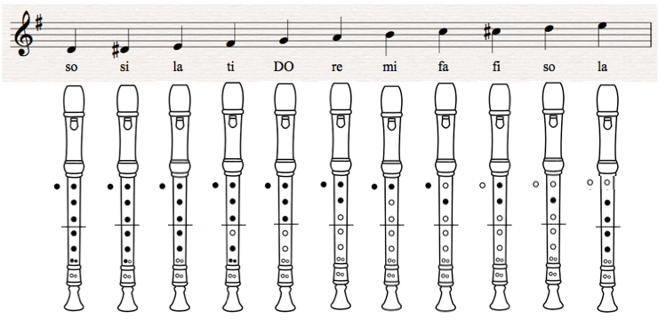

**4. _____________ 5. _____________ 6. _____________**

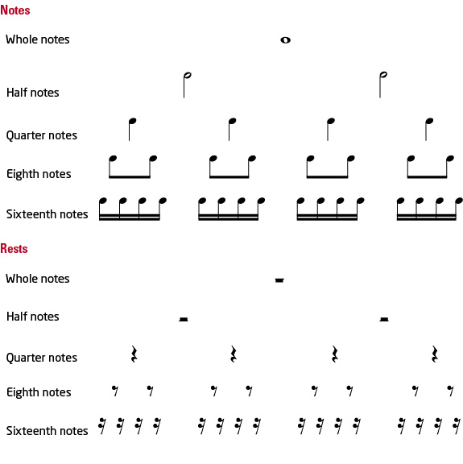

**Pitches**



**Use this information to fill in the answers above**

**Au Clair de la Lune**  
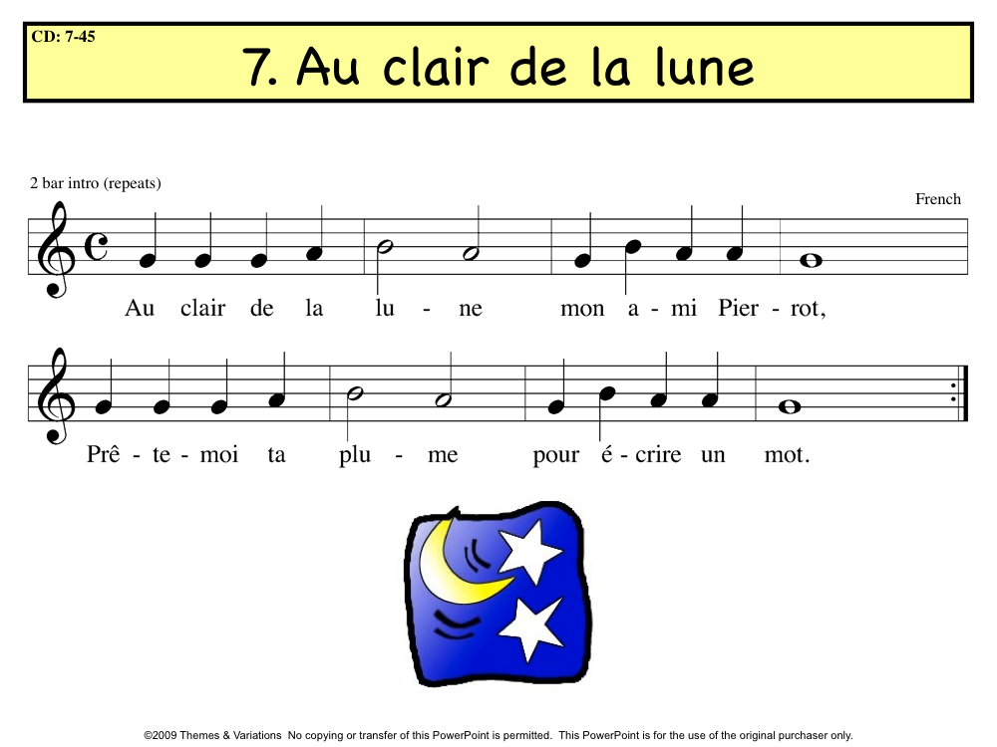

**Hot Cross Buns**

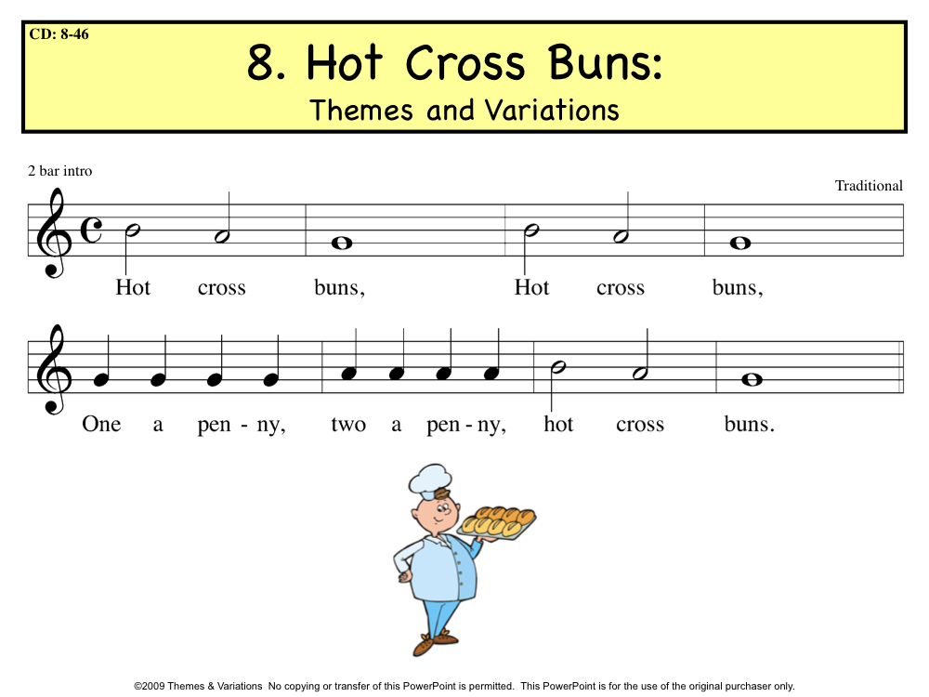

**Salish Hand Game**  
